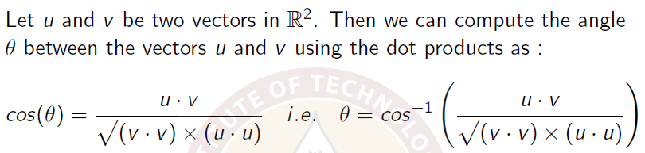



 Then,

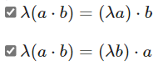





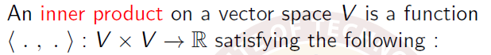

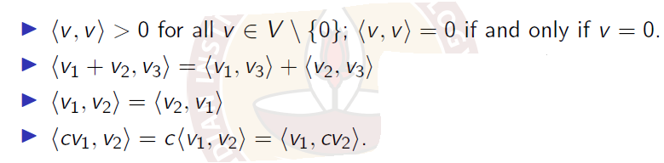

 

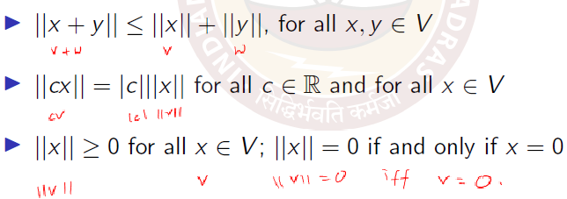



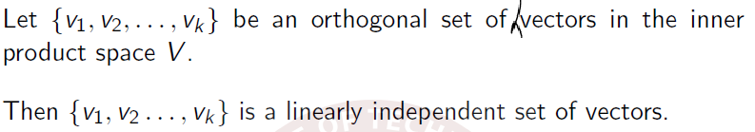



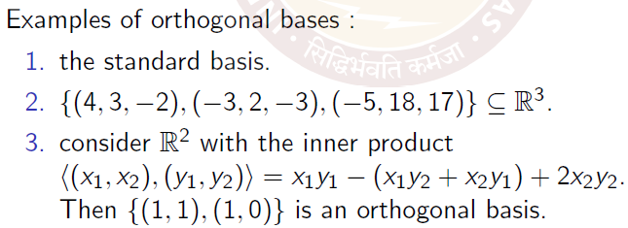

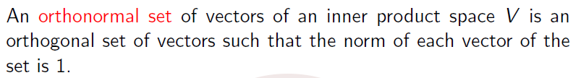

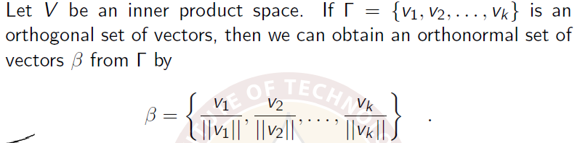

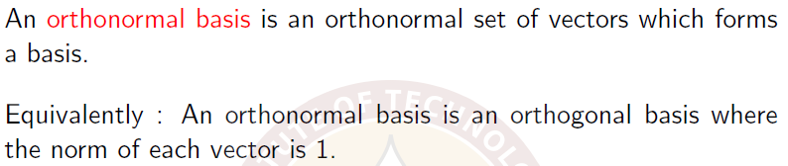

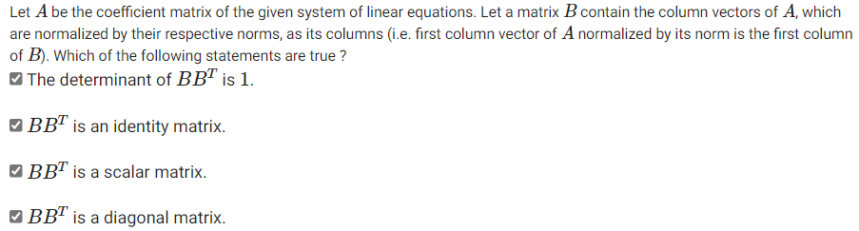

## Gram-Schmidt process to find orthonormal basis from a set of basis vectors

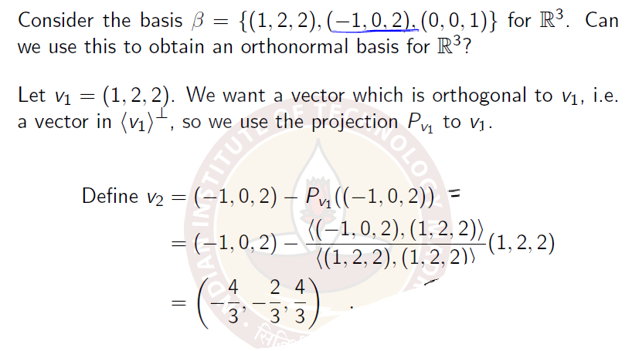

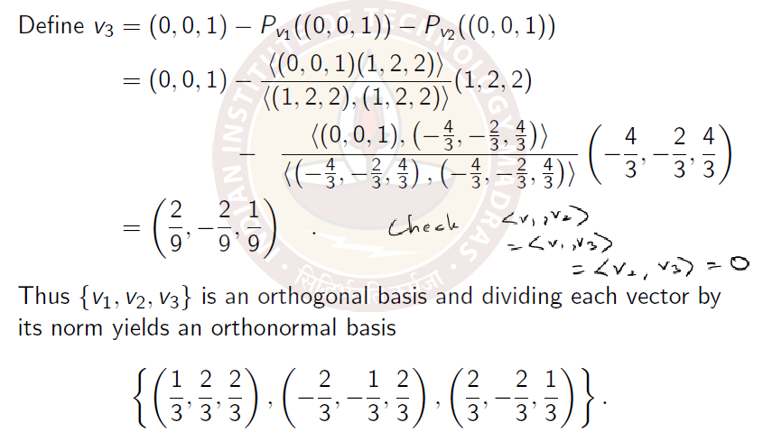



Then, 

## Week10

To prove continuity/discontinuity of a curve in two variables x and y at a specified point, consider y = mx. After substituting, if you get an expression in m, then it means the curve isn’t continuous since the limit value at the specified point depends on the value of m.